

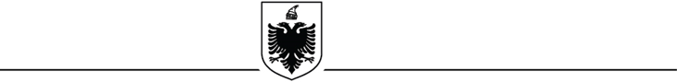

**REPUBLIKA E SHQIPËRISË**

**AUTORITETI PORTUAL DURRËS**

**DIVIZIONI LIGJOR DHE ADMINISTRATËS**

**SUMMARY CONTRACT NOTICE**

*(To be completed by the Contracting Authority/ Entity in order to be published to the*

*Public Notifications Bulletin)*

**1. Name and address of the contracting authority**

Name Durres Port Authority

Address Lagjja nr. 1, Rruga Tregtare, Durres

Tel/Fax +355 52 2 93422

E-mail: a.marku@durresport.al

Website www. durresport.al

**2. Type of procurement procedure:** “Restricted Procedure - above the upper monetary limit”.

**3. Reference number of procedure / lot: REF-14506-07-26-2024**.

**4. Object of the contract/framework agreement:**

**-** “New Integrated Commercial Port of Durres in Porto Romano – Phase 1”.

**5. Limit Fund**:

- 39.320.000.000 (thirty-nine billion three hundred twenty million) Lek, VAT excluded.

- 391.867.649,99 (three hundred ninety one million eight hundred sixty seven thousand six hundred forty nine point ninety nine) Euro, VAT excluded.

The official exchange rate, according to the Bank of Albania, on 26.07.2024 is 100.34 Lek/Euro.

**6.** **Duration of the contract/ framework agreement or deadline for its implementation:**

**-** 40 (forty) months.

**7. Deadline for the submission and opening of bids:** 16/09/2024; **Time:** 11:00.